Online Book Reselling System

In this project we have designed Online Resale Book system where users can sold their books online and other users can browse all book and then purchase desired books.

This project consists of following modules

Admin: admin can login to system using username and password as ‘admin’, ‘admin’after login admin can view list of registered users, list of books and orders.

User Signup: using this module new user can sign up with the application

User Login: using this module user can login to system

Sale Your Book(Add Books): using this module user can sale his book by uploading book details

View Books List: using this module users can see all books from sellers and can buy desired book by making dummy payment with card

My Orders: using this module user can view list of books he purchased online

My Sold Books: using this module user can see list of his sold books or buyer details

SCREEN SHOTS

First copy content from DB.txt file and then paste in MYSQL console to create database and then double click on ‘run.bat’ file to start python DJANGO web server and get below screen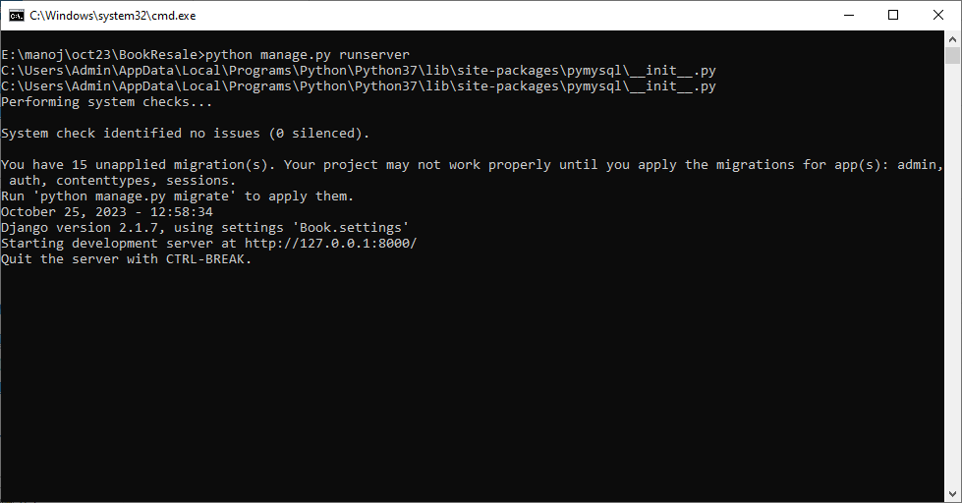

In above screen python DJANGO server started and now open browser and entre URL as <http://127.0.0.1:8000/> and press enter key to get below page

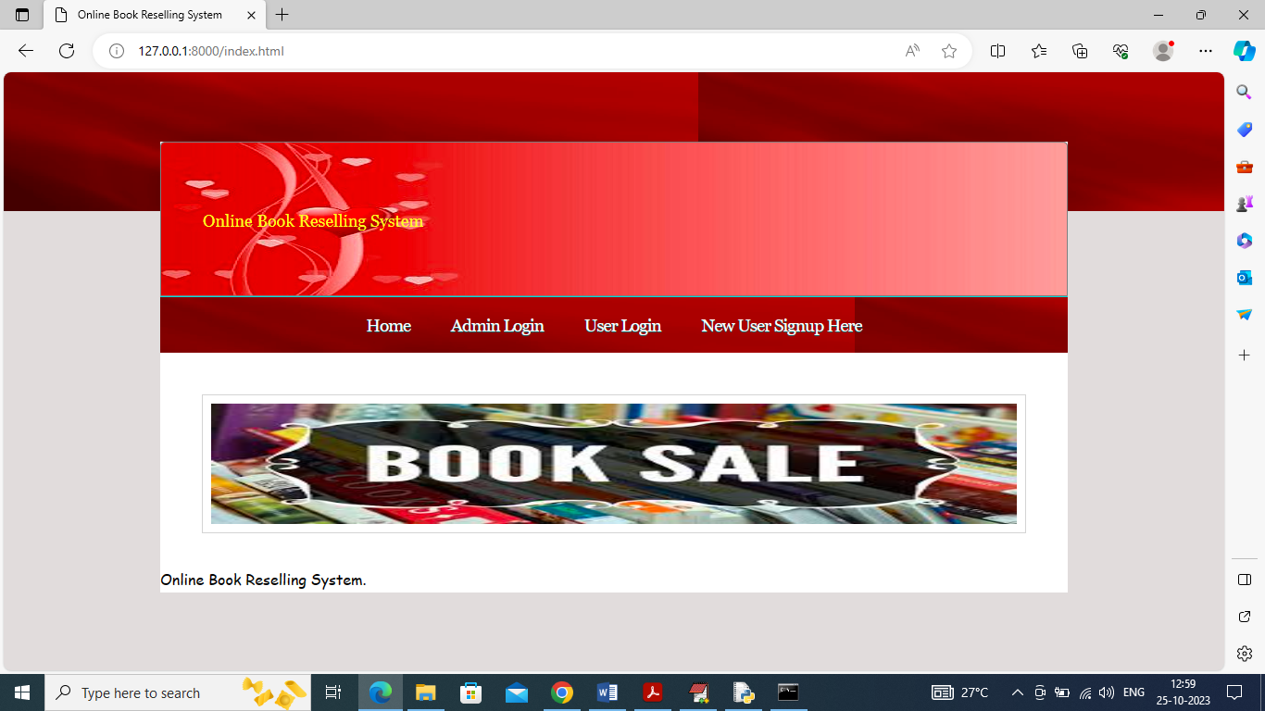

In above page user can click on ‘New User Signup’ link to get below page

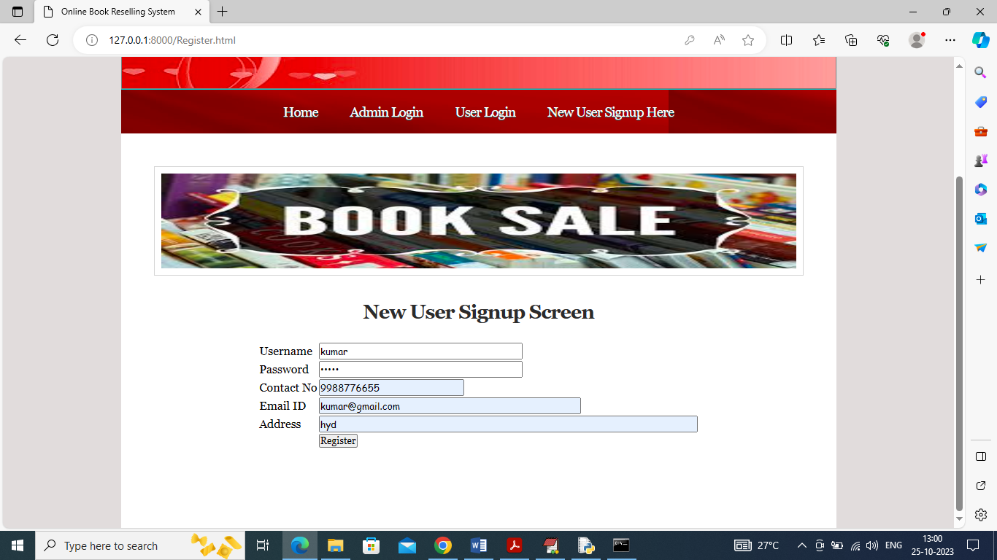

In above screen user is entering signup details and then press button to get below page

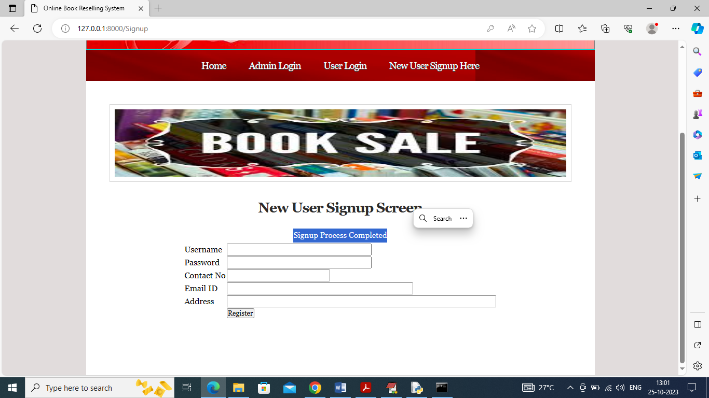

In above screen in blue colour text can see signup task completed and similarly you can add as many users as you want

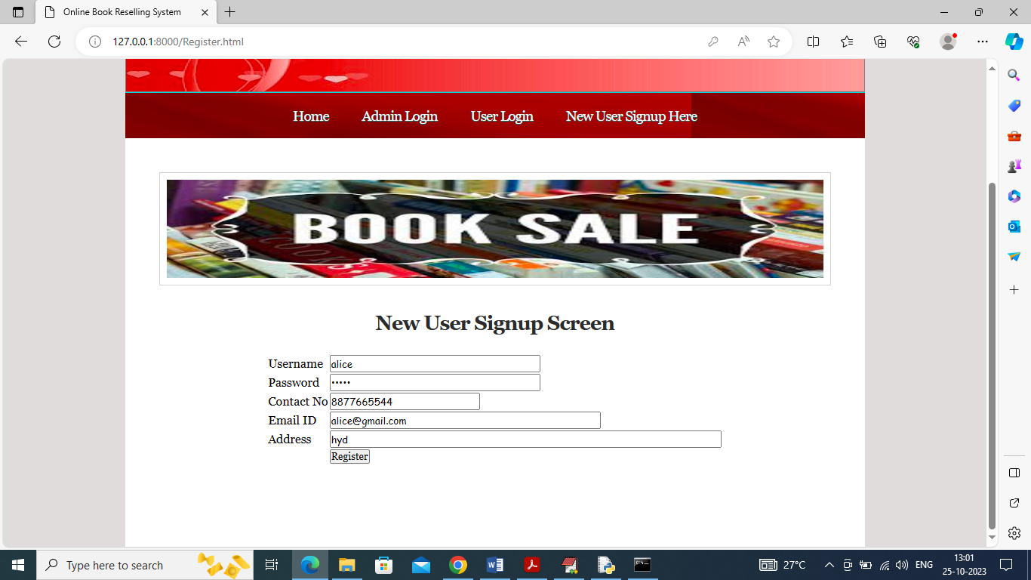

In above screen another user is signup and then press button to complete signup and now click on ‘User Login’ link to get below login page

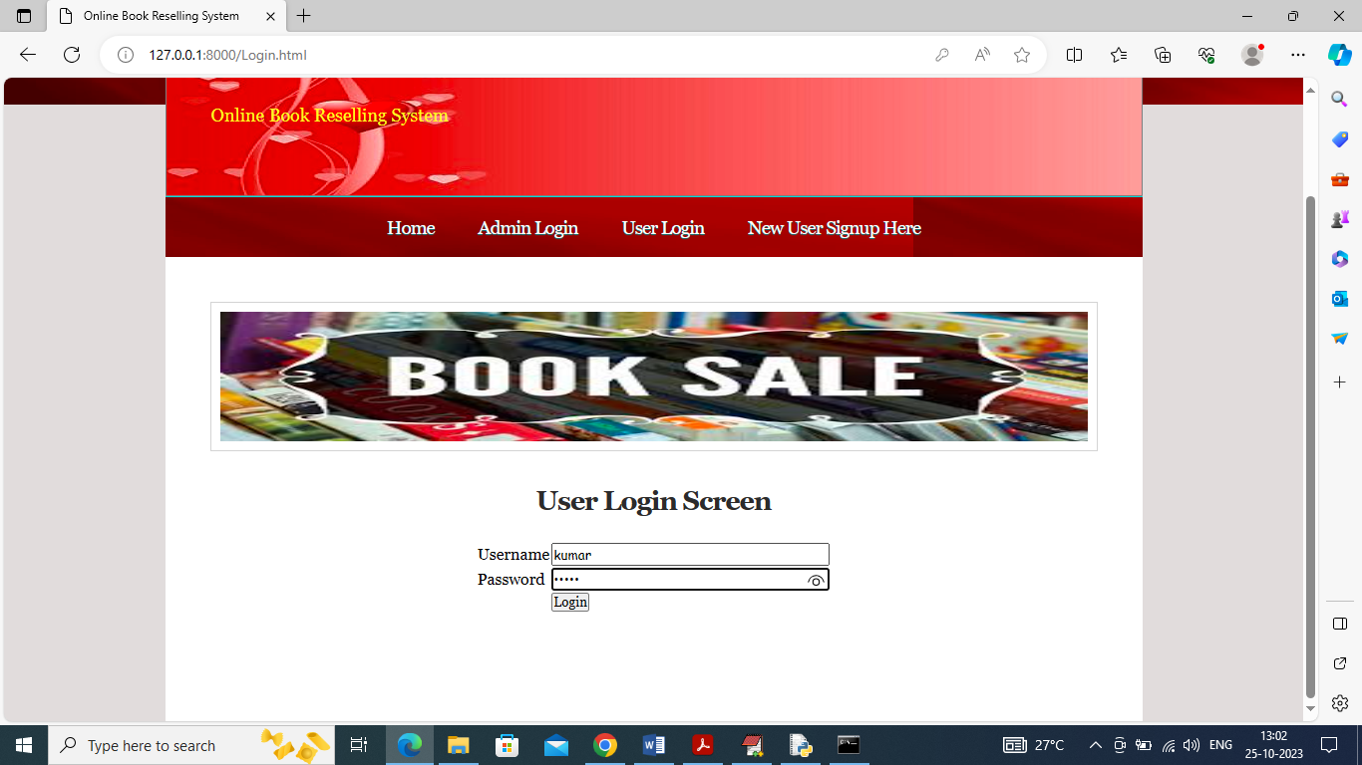

In above screen user is login and after login will get below page

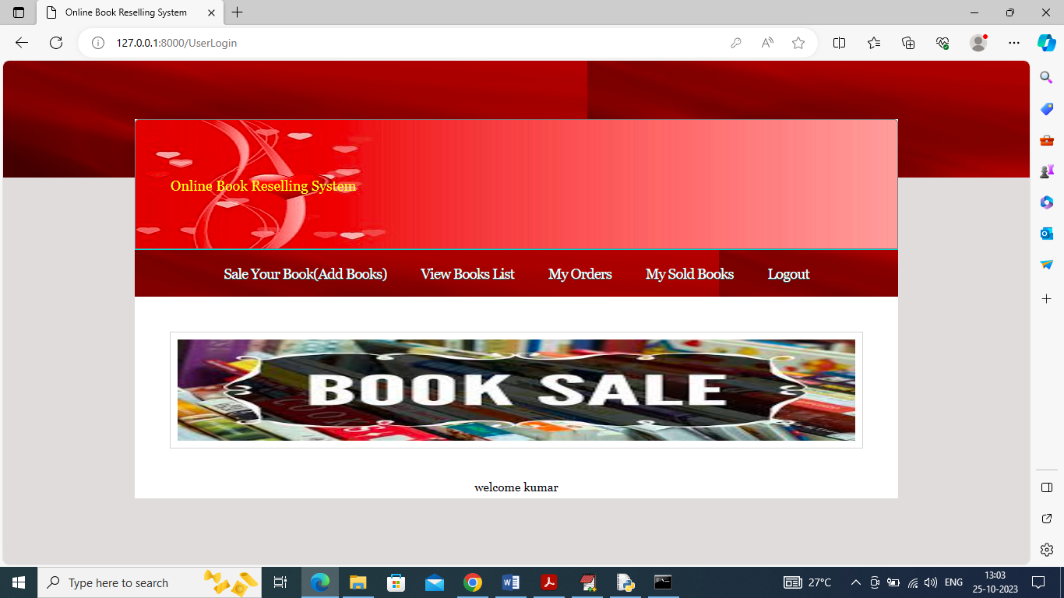

In above screen user can click on ‘Sale Your Book’ link to upload his book details for sale

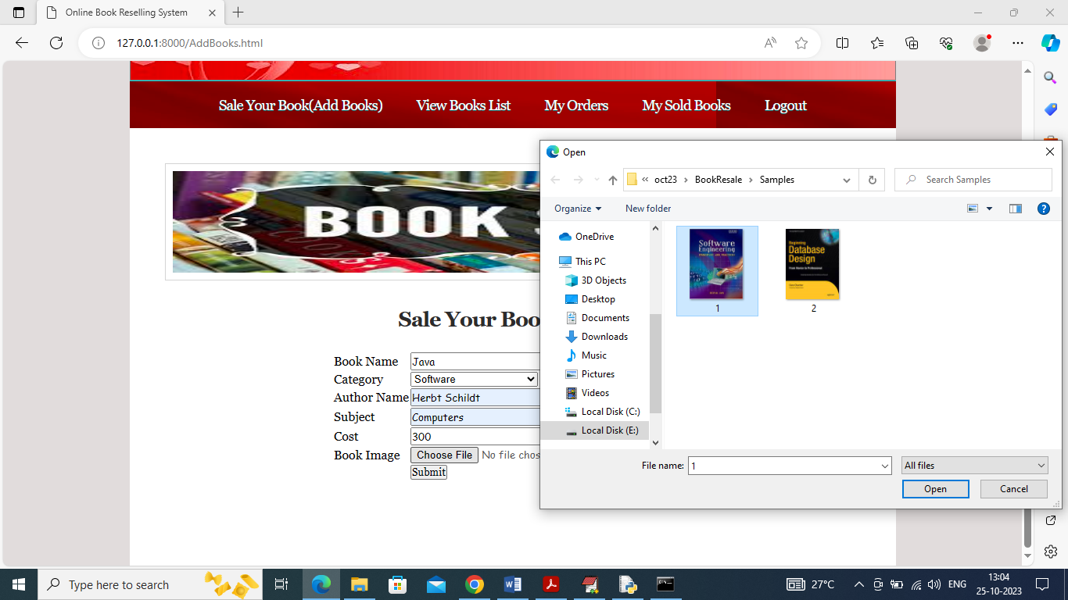

In above screen user is entering book details and can upload book image so user can view and purchase it and then press button to get below page

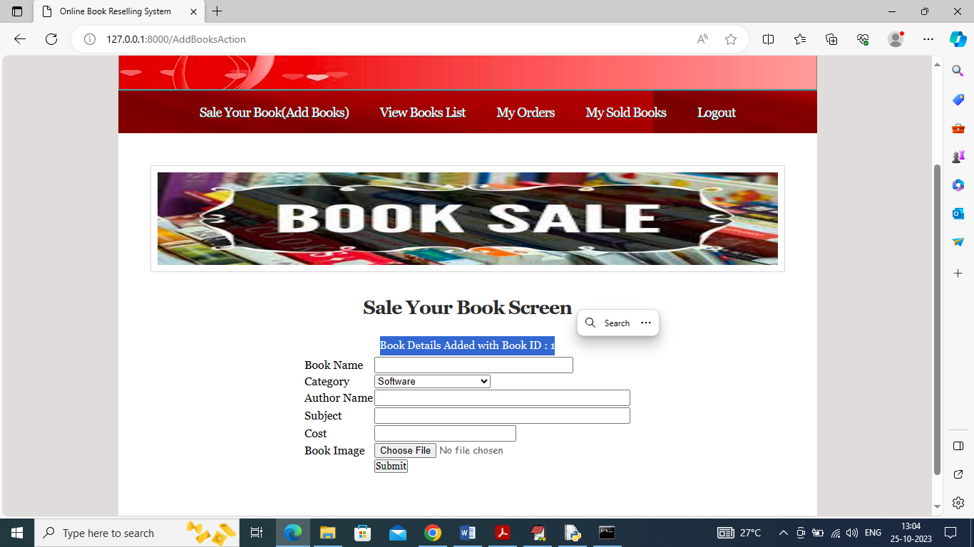

In above screen book is added with book ID 1 and similarly you can add as many book as you want. Now click on ‘View Books List’ to view list of uploaded books

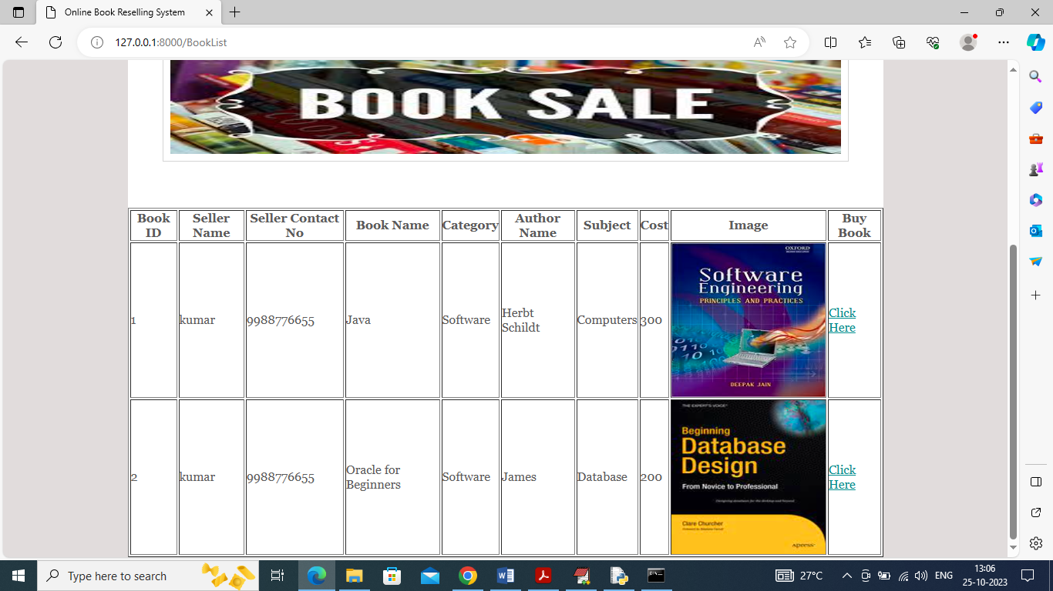

In above screen user can see details of all books and then click on ‘Click Here’ link to purchase books like below screen

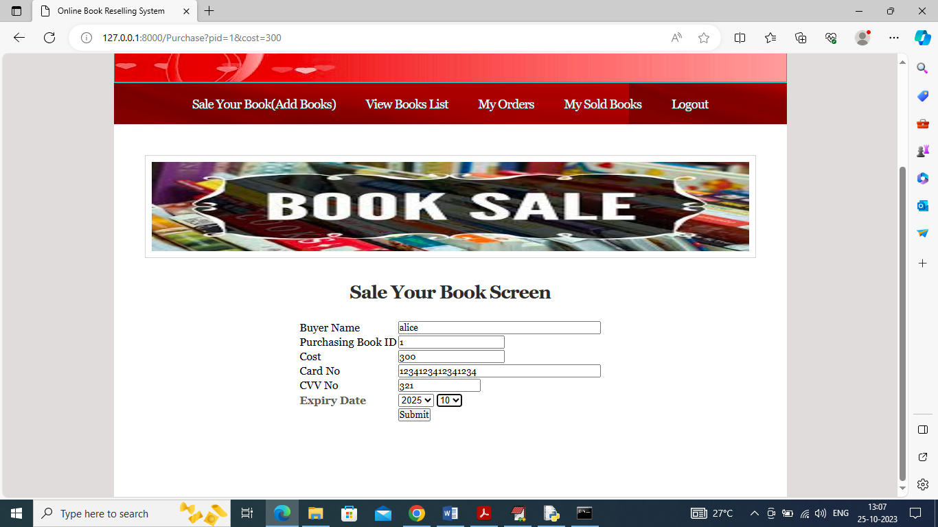

In above screen user can view buying book details and then enter payment details and press button to get below page

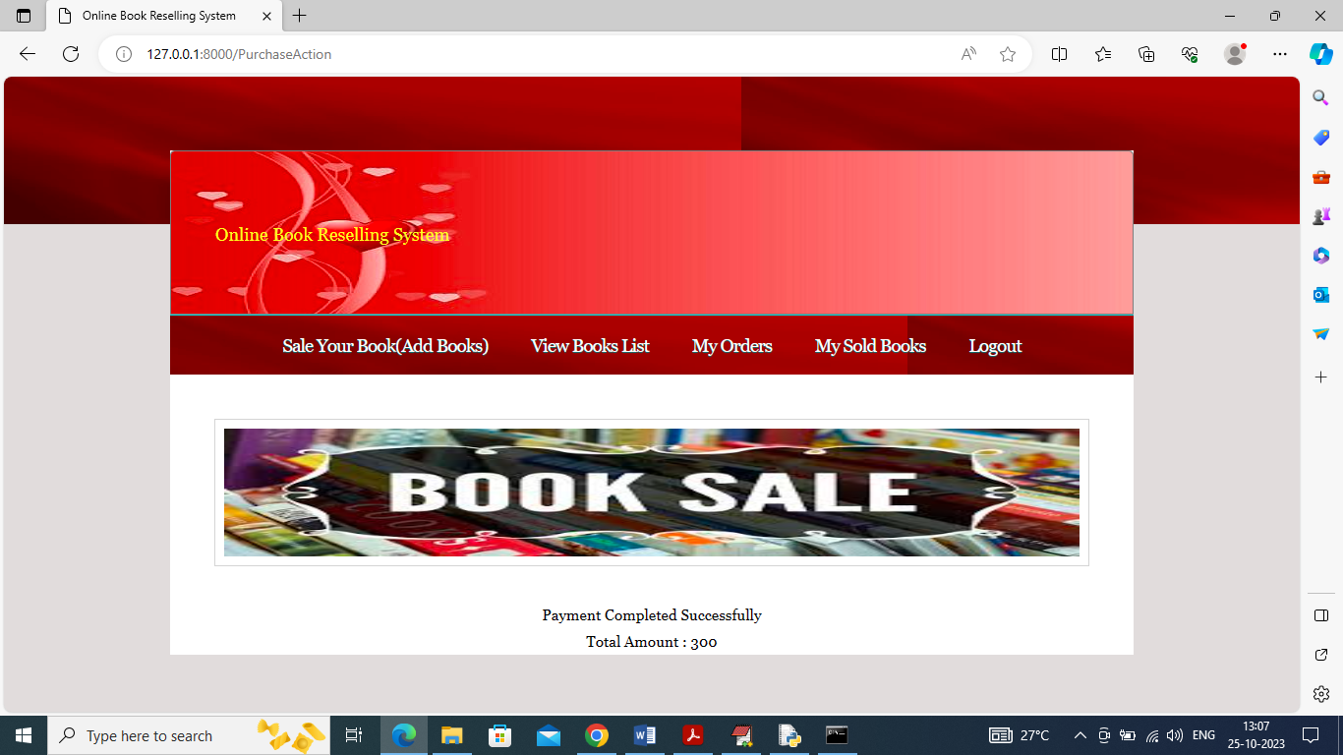

In above screen payment is completed and now user can click on ‘My Orders’ link to view all his past transaction like below screen

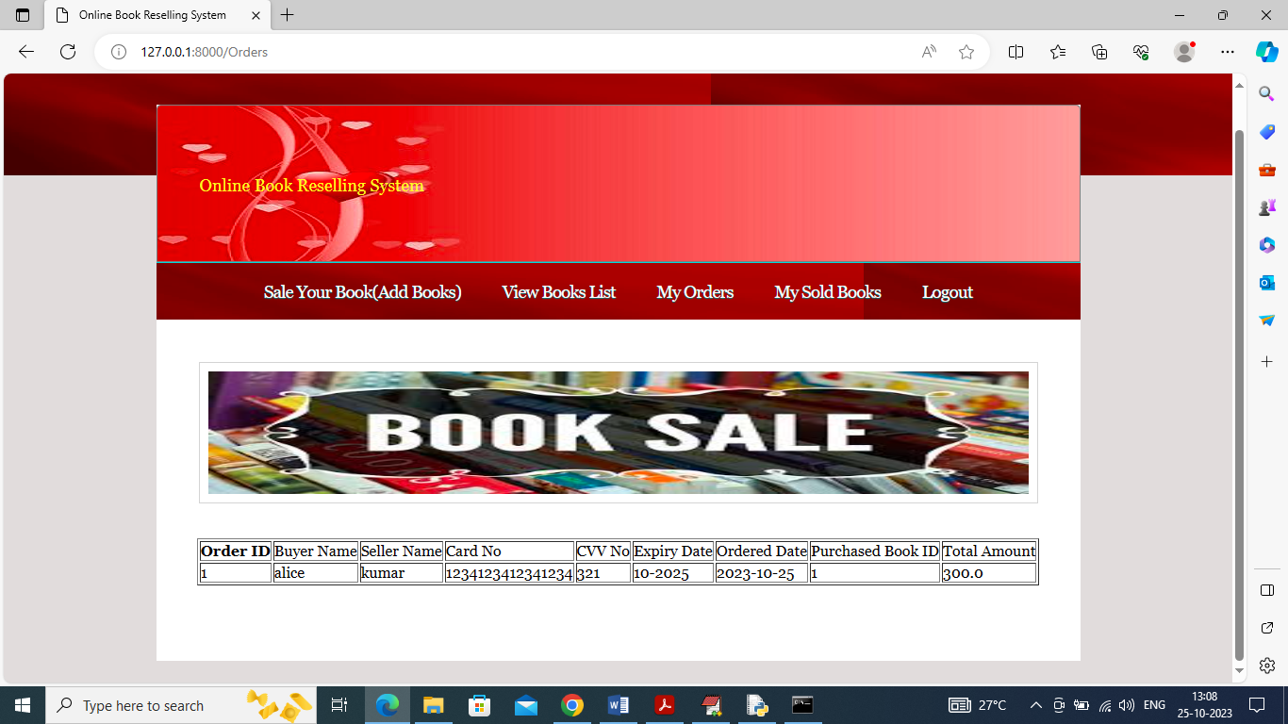

In above screen buyer can view all his past transactions and similarly seller can view all his sold book details with buyer name and now logout and login as seller to view his sold books

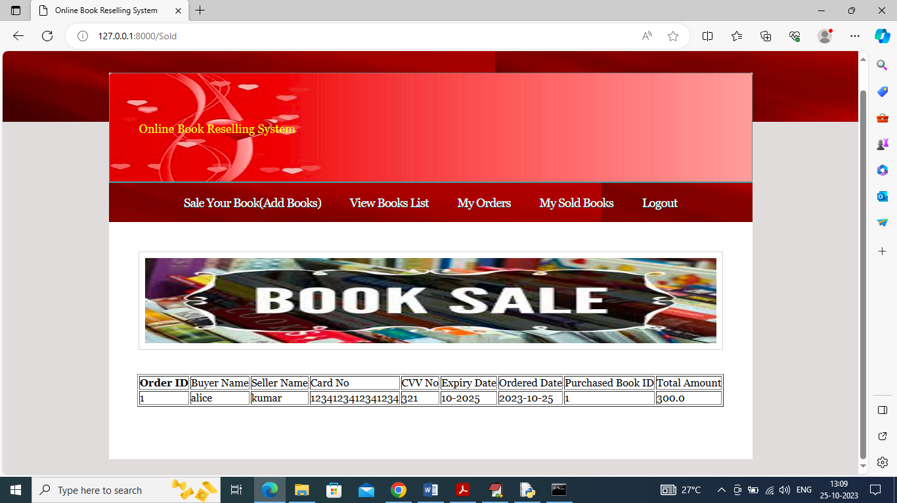

In above screen seller can view list of his book sold and now logout and login as ADMIN to view all details

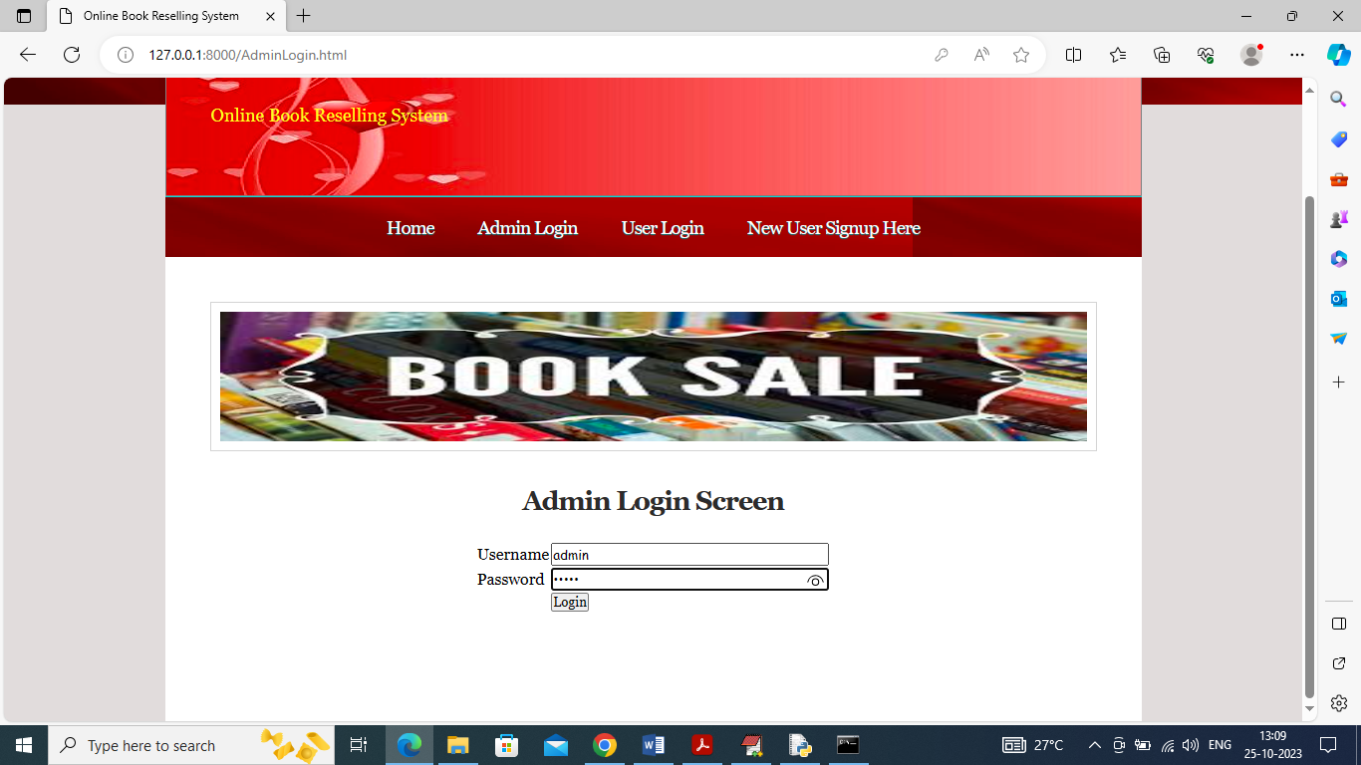

In above screen admin is login and after login will get below page

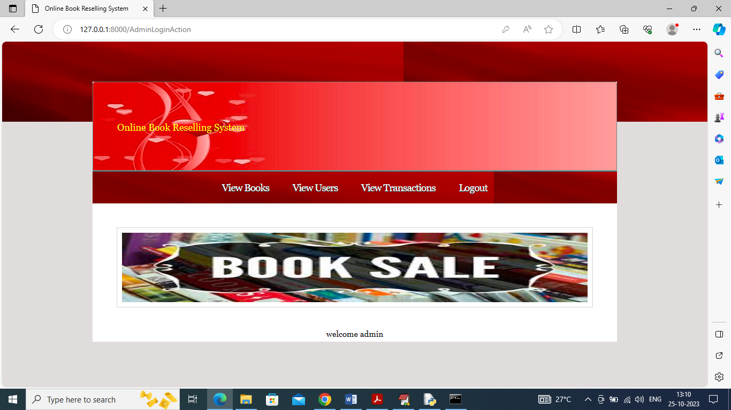

In above screen admin can click on ‘View Books’ link to view all book details like below screen

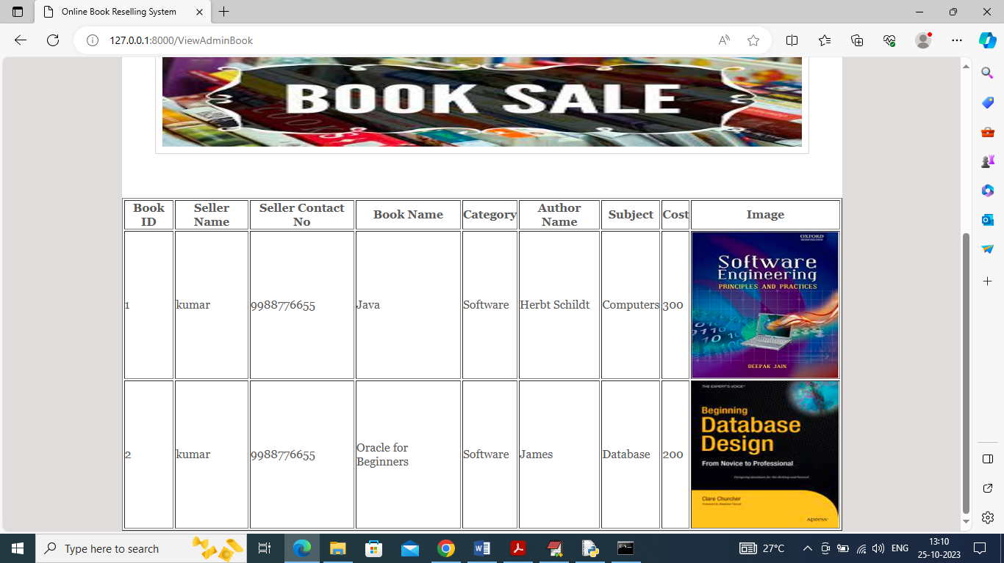

Now admin can click on ‘View Users’ link to get all registered user list like below page

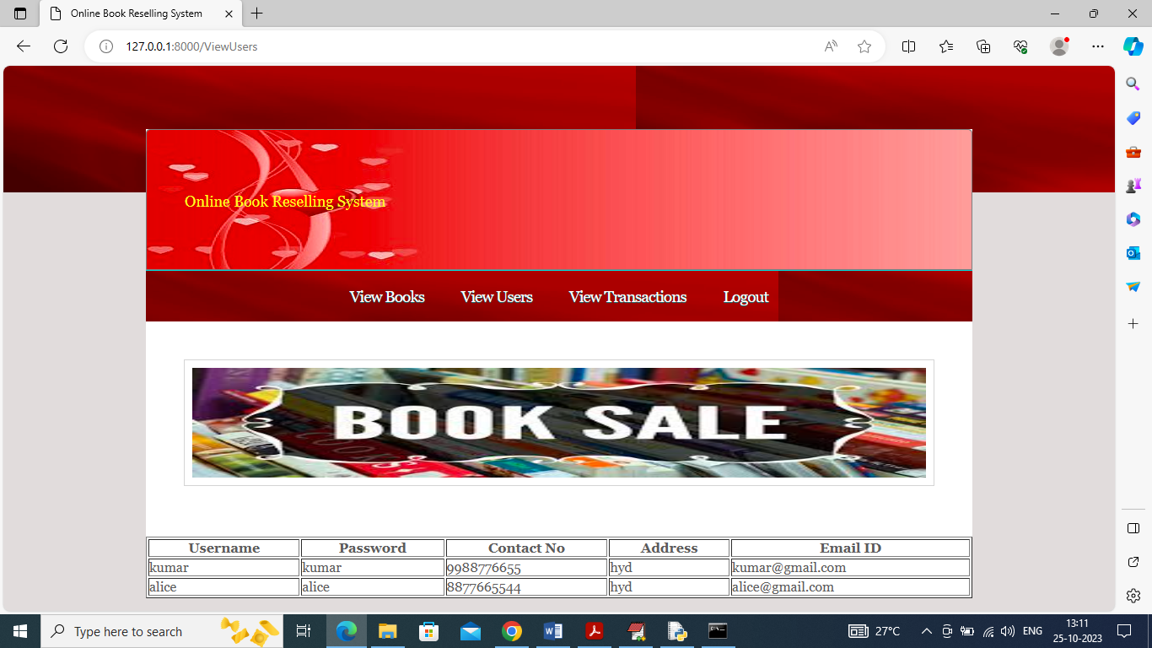

Now click on ‘View Transactions’ link so admin can view all purchase transactions like below page

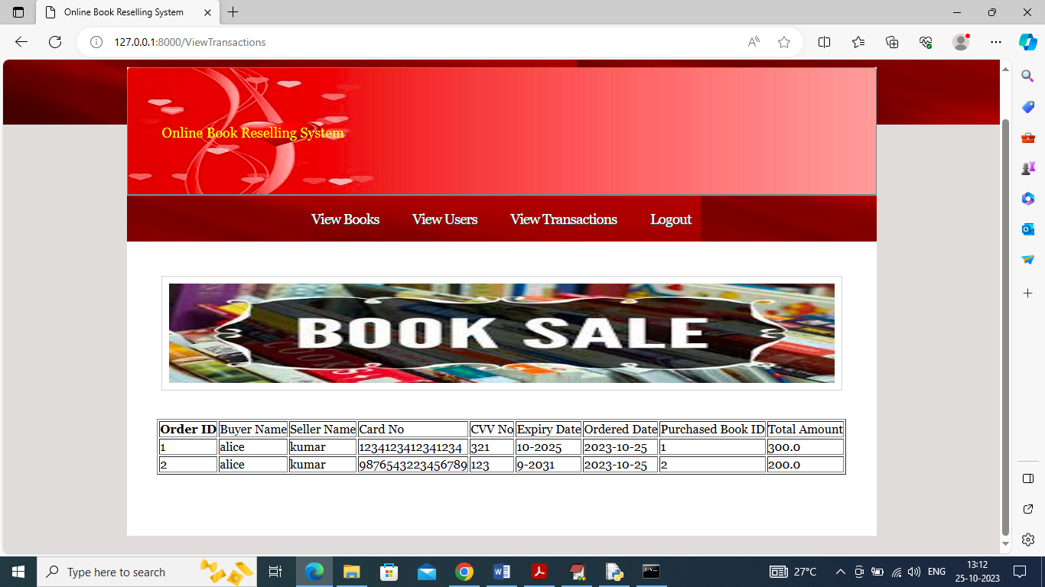

In above screen admin can view list of books purchase as transactions.

Similarly by following above screens you can add and purchase books online